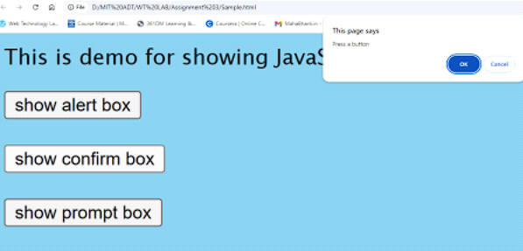
HTML code
<!DOCTYPE html>
<html lang="en">
<head>
<meta charset="UTF-8">
<meta name="viewport" content="width=device-width, initial-scale=1.0">
<title>JavaScript Dialog Boxes Demo</title>
<style>
body {
background-color: lightblue;
font-family: Arial, sans-serif;
text-align: center;
padding: 20px;
margin: 0;
}

h1 {
color: #333;
}

.box {
cursor: pointer;
padding: 10px;
border: 1px solid #ccc;
margin: 10px;
text-align: center;
background-color: white;
border-radius: 5px;
font-size: 16px;
font-weight: bold;
transition: none; /* No transition effects */
}
</style>
</head>
<body>
<h1>JavaScript Dialog Boxes Demo</h1>

<!-- Buttons for each dialog box -->
<div class="box" onclick="showAlert()">Show Alert Box</div>
<div class="box" onclick="showConfirm()">Show Confirm Box</div>
<div class="box" onclick="showPrompt()">Show Prompt Box</div>

<!-- Inline JavaScript -->
<script>
// Function to show an alert box
function showAlert() {
alert("This is an alert box!");
}

// Function to show a confirm box
function showConfirm() {
const result = confirm("Do you want to proceed?");
if (result) {
alert("You clicked OK!");
} else {
alert("You clicked Cancel!");
}
}

// Function to show a prompt box
function showPrompt() {
const userInput = prompt("Please enter something:");
if (userInput !== null) {
alert(`You entered: ${userInput}`);
} else {
alert("You clicked Cancel or closed the prompt.");
}
}
</script>
</body>
</html>

ptBox').addEventListener('click', showPromptBox);

